Mammoth Project Report

# Summary

This report summarizes a series of experiments focused on the development and characterization of protein-based therapeutic formulations, emphasizing immunoglobulin G (IgG) encapsulation in microspheres. Key activities included extensive screening of excipients to enhance protein solubility and stability, fabrication of polymer microspheres with controlled properties, and the application of various analytical methods to quantify protein loading and activity.

Formulation development demonstrated that excipient selection is critical for protein stability and solubility. Trehalose was identified as a more effective excipient than lactose for enhancing the solubility and stability of mammoth protein formulations. A broad screening of 13 potential additives assessed their solubility and viscosity, identifying several candidates for future formulation builds, though the high viscosity of materials like Polyacrylamide requires further investigation.

A central focus was the encapsulation of IgG into microspheres via a post-loading method. Microsphere porosity was successfully manipulated by varying PEG polymer concentrations, correlating with particle uniformity and yield. To improve loading efficiency, 21 different excipients were evaluated, with several, including Polyallylamine (HCl), Chitosan, and Lecithin, significantly improving IgG uptake. However, attempts to load hIgG into pre-formed microspheres under different time and concentration conditions resulted in negligible loading, highlighting the need for optimized protocols.

Various analytical assays were employed and validated. The BCA assay was established as the primary method for protein quantification, with its suitability confirmed for enzymes like HRP and APT. The PLGA polymer matrix from microspheres exhibited minimal interference with the BCA reagent. Additionally, dot blot immunoassays were developed to assess the retained biological activity of encapsulated antibodies and improve detection specificity, revealing that the encapsulation process had minimal negative effects on antibody function. These studies identified promising formulation strategies and excipients for protein delivery and established the analytical framework necessary for their characterization.

# Introduction

The development of stable, long-acting formulations for therapeutic proteins, particularly immunoglobulin G (IgG), presents significant challenges in biopharmaceutical research. Key obstacles include achieving high protein concentration without compromising solubility, ensuring stability throughout the formulation process, and developing effective controlled-release delivery systems. Encapsulation within polymer microspheres is a promising strategy for sustained delivery, but it introduces complexities such as low or inconsistent loading efficiency and the need for precise control over microsphere characteristics like porosity and density. Furthermore, accurate quantification of encapsulated protein and validation of its retained activity are critical for assessing formulation performance, necessitating robust analytical methods that are not susceptible to interference from formulation components.

This work systematically addresses these challenges through a comprehensive investigation into formulation and analytical development. The efforts include: 1) extensive screening of a wide range of excipients to identify candidates capable of enhancing IgG solubility and improving loading into microspheres; 2) fabrication and characterization of blank microspheres using different polymers and process parameters to optimize physical properties for subsequent protein loading; and 3) the development, optimization, and validation of multiple analytical techniques, including BCA, ELISA, and dot blot assays, to accurately quantify protein concentration and assess potential interference from materials like PLGA and various additives. The primary goal is to establish a foundational understanding of the key parameters governing the successful formulation and characterization of a controlled-release IgG product.

# Objectives

1. Develop and optimize formulations for encapsulating therapeutic proteins, such as Immunoglobulin G (IgG), within polymer microspheres.

2. Evaluate the effects of various excipients, polymers, and formulation parameters on key characteristics including solubility, stability, loading efficiency, and release profile.

3. Establish and validate analytical methods, including BCA, ELISA, and dot blot assays, for quantifying protein concentration and assessing retained biological activity.

4. Characterize the physical properties of formulations, such as particle morphology, porosity, and viscosity, to ensure suitability for the intended application.

# Methodology

## Microsphere Fabrication and Characterization

Blank poly(lactic-co-glycolic acid) (PLGA) microspheres were fabricated to evaluate the effects of polymer concentration on physical characteristics. A series of five formulations (MA14-MA18) were prepared using PEG polymer (Expansorb PO26) dissolved in 3000 µL of dichloromethane (DCM). The polymer concentration was varied with formulations containing 600 mg (20%), 300 mg (10%), 150 mg (5%), 60 mg (2%), and 30 mg (1%) of the polymer. Following fabrication, aliquots of the resulting microsphere yield from each batch were collected for morphological analysis. The size, shape, and density of the particles were assessed using a ZOE Microscope, while surface characteristics, including porosity and texture, were examined using Scanning Electron Microscopy (SEM).

## Excipient and Additive Screening

Screening studies evaluated the properties of various excipients and additives for potential use in formulations, focusing on automated dispensing, solubility, compatibility, and viscosity.

Solid excipients were dispensed using a pre-calibrated SDB-1 automated dispenser. Each material was dispensed three times to confirm that the dispensed amount was within 1 mg of the target value. The specific SDB-1 disk size and vibration settings were recorded for each material, as detailed in [TABLE_1]. Materials that could not be dispensed reliably, such as Sodium Oleate and Dextran Sulfate, were noted. Liquid excipients, including Polysorbate 80 and Castor Oil, were dispensed by volume.

**Table 1: SDB-1 Calibration Parameters for Excipient Dispensing**

|  |  |  |  |
| --- | --- | --- | --- |
| Material | SDB1 Disk Size | Vibration | Amount Dispensed (mg) |
| Povidone K-30 | 2 | 2 | 2.6 |
| Benzethonium Chloride | 2 | 2 | 5.2 |
| Sodium Oleate | 2 | 2 | Didn't work repeatedly |
| Trehalose | 2 | 2 | 6.1 |
| Sodium Alginate | 2 | 3 | 7 |
| Sorbitol | 2 | 2 | 4 |
| Ethyl Cellulose 48% Ethoxy Content | 2 | 2 | 3.6 |
| Arginine | 2 | 2 | 5.7 |
| Dextran Sulfate 500k MW | 2 | 2 | Didn't work repeatedly |
| Glycine | 2 | 2 | 6 |
| Aqualon CMC | 2 | 2 | 5 |
| Ammonium Sulfate | 2 | 2 | 7 |
| PEG 3350 | 2 | 2 | 4.5 |
| Polysorbate 80 |  |  | 100 µL |
| Castor Oil |  |  | 100 µL |

Following dispensing into a 24-well NUNC plate, the solubility of each excipient was tested by adding 900 µL of various solvents, including Acetonitrile, Ethanol, N-Methyl-2-pyrrolidone (NMP), Dimethyl sulfoxide (DMSO), Dichloromethane (DCM), Acetone, Phosphate-Buffered Saline (PBS), and water. The qualitative solubility results are summarized in [TABLE_2].

**Table 2: Qualitative Solubility of Excipients in Various Solvents**

|  |  |  |  |
| --- | --- | --- | --- |
| Material | Solvent | Material Amount | Soluble? |
| Povidone K-30 | Acetonitrile, Ethanol, NMP, DMSO, DCM, Acetone, PBS, Water | ~2.6 mg | Partial, Yes, Yes, Yes, Yes, Yes, Yes, Yes |
| Benzethonium Chloride | Acetonitrile, Ethanol, NMP, DMSO, DCM, Acetone, PBS, Water | ~5.2 mg | Partial, No, Yes, Yes, Yes, Yes, Partial, No |
| Sodium Oleate | DCM, Acetone, PBS, Water | 9-11.5 mg | No, Yes, Partial, Yes |
| Trehalose | Acetonitrile, Ethanol, NMP, DMSO, DCM, Acetone, PBS, Water | ~6.1 mg | No, Partial, Yes, Yes, Yes, No, Yes, Yes |
| Sodium Alginate | Acetonitrile, Ethanol, NMP, DMSO, DCM, Acetone, PBS, Water | ~7 mg | No, No, Partial, Partial, Partial, No, Yes, Yes |
| Sorbitol | Acetonitrile, Ethanol, NMP, DMSO, DCM, Acetone, PBS, Water | ~4 mg | No, No, Yes, Yes, No, No, Yes, Yes |
| Ethyl Cellulose 48% Ethoxy content | Acetonitrile, Ethanol, NMP, DMSO, DCM, Acetone, PBS, Water | ~3.6 mg | Partial, No, Yes, Yes, Yes, Yes, No, No |
| Arginine | Acetonitrile, Ethanol, NMP, DMSO, DCM, Acetone, PBS, Water | ~5.7 mg | No, No, Partial, Partial, No, Yes, Yes, Yes |
| Glycine | Acetonitrile, Ethanol, NMP, DMSO, DCM, Acetone, PBS, Water | 6 mg | No, No, Partial, No, No, Partial, Yes, Yes |
| Aqualon CMC | Acetonitrile, Ethanol, NMP, DMSO, DCM, Acetone, PBS, Water | 5 mg | No, No, No, No, No, No, Yes, Yes |
| Ammonium Sulfate | Acetonitrile, Ethanol, NMP, DMSO, DCM, Acetone, PBS, Water | ~7 mg | No, No, Yes, Partial, Partial, Partial, Yes, Yes |
| PEG 3350 | Acetonitrile, Ethanol, NMP, DMSO, DCM, Acetone, PBS, Water | ~4.5 mg | Yes, No, Partial, Partial, Yes, Partial, Yes, Yes |
| Polysorbate 80 | Acetonitrile, Ethanol, NMP, DMSO, DCM, Acetone, PBS, Water | 100 µL | Yes, Yes, Yes, Yes, Yes, Yes, Yes, Yes |
| Castor Oil | Acetonitrile, Ethanol, NMP, DMSO, DCM, Acetone, PBS, Water | 100 µL | No, Yes, Yes, Yes, Yes, Yes, No, No |

The compatibility of 13 potential additives was assessed by observing precipitation upon mixing. In a 96-well plate, 50 µL of each additive solution was combined with 2 drops of DCM, followed by 250 µL of PVA solution. The plate layout for this screening is shown in [TABLE_3]. Wells were visually inspected for crashing, and an absorbance scan was performed at 230 nm to detect changes not visible to the naked eye. This wavelength was determined to be optimal by an initial scan of Ethyl Cellulose from 230 nm to 600 nm.

**Table 3: Plate Map for Additive Compatibility Screening**

|  |  |
| --- | --- |
| Well | Additive |
| A1 | Ammonium Sulfate |
| A2 | Poly-L-Lysine |
| A3 | Polyethyleneimine |
| A4 | Polysorbate 80 |
| A5 | Alginic Acid |
| A6 | Dextran Sulfate |
| A7 | Heparin |
| A8 | Polyacrylamide |
| A9 | Chitosan |
| A10 | Polyallylamine |
| A11 | Arginine |
| A12 | Ethyl Cellulose |
| B1 | Sodium Hyaluronate |
| B2 | Blank (DI H2O) |

A qualitative viscosity study was performed on additives that were difficult to aspirate with a pipettor. The candidates—Polyacrylamide, Chitosan, and Sodium Hyaluronate—were serially diluted (2x) from their stock concentrations (10 mg/mL or 5 mg/mL). Viscosity was evaluated based on the ease of pipetting, and the concentration at which each solution became "free flowing" was determined. Additionally, a separate experiment was conducted to determine if certain additives could improve the solubility of Immunoglobulin G (IgG) in PBS at a high concentration (200 mg/mL). Stock solutions of additives were prepared and added to IgG in a 96-well plate, which was then mixed by gentle pipetting to observe any changes in solubility. The additives and concentrations tested are listed in [TABLE_4].

**Table 4: Additives and Concentrations for IgG Solubility Screening**

|  |  |  |  |
| --- | --- | --- | --- |
| Additive | Concentration 1 | Concentration 2 | Concentration 3 |
| Sodium chloride | 0.15M | 6.2 mg/mL |  |
| Polysorbate 80 | 0.05 mg/mL | 0.7 mg/mL | 1 mg/mL |
| Sodium citrate | 0.001 M | 0.03M |  |
| pH | 5.2 | 6.0 | 7.2 |
| EDTA | 0.02 mg/mL | 0.056 mg/mL | 0.14 mg/mL |
| Histidine | 0.004 M | 0.02 M | 0.49 mg/mL |
| Trehalose | 20 mg/mL | 80 mg/mL | 0.175 M |
| Polysorbate 20 | 0.08 mg/mL | 0.4 mg/mL |  |
| Sorbitol | 16 mg/mL |  |  |
| PEG 3350 | 4.7 mg/mL |  |  |
| Sodium Phosphate | 0.006 M | 0.05 M |  |
| Sucrose | 25 mg/mL | 50 mg/mL | 90 mg/mL |
| Sodium Succinate | 0.05 M |  |  |
| Mannitol | 12 mg/mL |  |  |
| Sodium Acetate | 0.01 M | 0.025 M |  |
| Adipic acid | 0.02M |  |  |
| Methionine | 0.2 mg/mL | 4.4 mg/mL |  |
| Arginine | 10 mg/mL |  |  |
| Poloxamer 188 | 0.2 mg/mL | 1.5 mg/mL |  |

## Post-Loading of IgG into Microspheres

The efficiency of post-loading human IgG (hIgG) into blank microspheres was investigated by varying incubation conditions and screening different excipients. Blank microspheres (MA14 and MA16) were selected based on differing porosity and density. To optimize loading conditions, 10 mg of microspheres were incubated in 0.5 mL of hIgG solutions at room temperature with occasional agitation. One experiment varied incubation time (1, 2, or 7 days) using a 1 mg/mL hIgG solution in PBS. A second experiment varied the hIgG concentration (0.2, 1.0, or 5.0 mg/mL in PBS, plus a 1.0 mg/mL solution in PBS with 0.1% PVA) for a fixed 1-day incubation. After incubation, free IgG was removed by washing the microspheres three times with 1 mL of TE buffer.

To assess the impact of excipients on loading efficiency, 10 mg of blank MA15 microspheres were incubated for 24 hours at room temperature in a solution containing 1 mg/mL hIgG and 1 mg/mL of one of 21 different excipients. Following incubation, the spheres were washed twice with 1 mL PBS to remove unloaded IgG and excipient. The spheres were then dissolved in 1 mL of DMSO for quantification of loaded IgG via BCA assay. The loading efficiency for each excipient is presented in [TABLE_5].

**Table 5: Effect of Excipients on Post-Loading of hIgG into MA15 Microspheres**

|  |  |  |  |
| --- | --- | --- | --- |
| Formulation # | Excipient | hIgG Loading | Improved Loading? (Y/N) |
| 1 | Alginic acid | 1.48% | Y |
| 2 | Ammonium sulfate | 1.04% | N |
| 3 | Castor oil | 1.10% | N |
| 4 | Dextran 40 | 1.14% | N |
| 5 | Distearoyl-Phosphocholine | 1.44% | Y |
| 6 | Polyallylamine, HCl | 2.57% | Y |
| 7 | Polysorbate 80 | 1.84% | ? |
| 8 | Arginine, HBr | 0.99% | N |
| 9 | Benzethonium chloride | 3.82% | ? |
| 10 | Chitosan | 3.74% | Y |
| 11 | Lecithin 4C | 2.64% | Y |
| 12 | Polyacrylamide | 1.56% | Y |
| 13 | Polyethyleneimine | 1.06% | N |
| 14 | Povidone (PVP) K30 | 1.21% | Y |
| 15 | Agarose, low gelling point | 1.89% | Y |
| 16 | Dextran sulfate | 1.07% | N |
| 17 | Ethyl cellulose | 1.96% | Y |
| 18 | Heparin 4C | 1.09% | N |
| 19 | Poly-L-Lysine 20C | 1.80% | ? |
| 20 | Sodium hyaluronate 4C | 1.18% | N |
| 21 | Span 80 | 1.08% | N |

## Analytical Methods for Quantification and Activity

Protein and enzyme concentrations were quantified using a BCA protein assay kit in a microplate format. A BCA working reagent was prepared by mixing 50 parts of Reagent A with 1 part of Reagent B. For analysis, 25 µL of each standard or unknown sample was pipetted into the wells of a 96-well NUNC plate, followed by the addition of 200 µL of the working reagent. The plate was shaken for 30 seconds, covered, and incubated at 37°C for 30 minutes. After cooling to room temperature, the absorbance was measured at 562 nm using a plate reader. For loading studies, microsphere samples were dissolved in DMSO at 10 mg/mL, and standards were prepared by serial dilution of a stock protein (e.g., IgG, HRP, or APT) in DMSO. For release studies, standards were prepared in the corresponding release buffer (e.g., PBS). A preliminary test confirmed that blank PLGA microspheres dissolved in DMSO showed minimal interference with the BCA reagents at relevant concentrations.

The presence of active alkaline phosphatase released from microspheres (MA10, MA12) was determined using a BCIP/NBT (5-bromo-4-chloro-3-indolyl phosphate/nitro blue tetrazolium) substrate assay, with Blank 12 microspheres serving as a negative control. Microsphere suspensions (1 mg/mL) were prepared in 1M TRIS buffer. A BCIP/NPT working solution was made by adding 2 drops each of Reagent 1, 2, and 3 to 5 mL of 1M TRIS buffer and mixing. 100 µL of this working solution was added to each microsphere suspension, vortexed, and centrifuged for 1 minute at 1000 rpm. The supernatant was decanted, and the pellet was washed by resuspending in 1 mL of 1M TRIS buffer, followed by another centrifugation and decanting step. The pellet was resuspended a final time in 1 mL of 1M TRIS buffer and incubated for 30 minutes. A positive result for AP activity was indicated by the development of an indigo color.

Dot blot and ELISA methods were employed to assess antibody activity and specificity. For dot blot assays, antigens (e.g., mouse IgG dilutions from 1 mg/mL to 0.1 µg/mL) were spotted onto nitrocellulose membranes. After blocking with 1x casein block, membranes were incubated with a sequence of antibodies, typically Goat anti-Mouse IgG, followed by Biotinylated Rabbit anti-Goat IgG (1:500 dilution), and finally a streptavidin conjugate (SAV-HRP or SAV-AP). Visualization was achieved using either TMB or BCIP substrate. Human IgG was used as a negative control to assess non-specific binding.

For ELISA optimization, various dilutions of biotinylated Rabbit anti-Goat (b-RxG) and SAV-HRP were tested, with optimal conditions determined to be 1:10,000 for b-RxG and 1:5,000 for SAV-HRP. For sample analysis, standards (e.g., mIgG from 100 µg/mL) and samples (e.g., MA228) were prepared in 2% BSA in PBST before being added to the plate for the assay sequence.

# Results

## Screening of Excipients and Additives

Initial studies focused on the characterization and screening of various excipients for solubility and compatibility. The SDB-1 powder dispenser was calibrated for multiple solid materials. The dispensed amounts for a set disk size and vibration level were recorded (Table 1). Sodium Oleate and Dextran Sulfate 500k MW could not be dispensed repeatedly with the tested settings.

**Table 1: SDB-1 solid dispenser calibration settings and dispensed amounts for various excipients.**

|  |  |  |  |
| --- | --- | --- | --- |
| Material | SDB1 Disk Size | Vibration | Amount Dispensed (mg) |
| Povidone K-30 | 2 | 2 | 2.6 |
| Benzethonium Chloride | 2 | 2 | 5.2 |
| Sodium Oleate | 2 | 2 | Didn't work repeatedly |
| Trehalose | 2 | 2 | 6.1 |
| Sodium Alginate | 2 | 3 | 7 |
| Sorbitol | 2 | 2 | 4 |
| Ethyl Cellulose 48% Ethoxy Content | 2 | 2 | 3.6 |
| Arginine | 2 | 2 | 5.7 |
| Dextran Sulfate 500k MW | 2 | 2 | Didn't work repeatedly |
| Glycine | 2 | 2 | 6 |
| Aqualon CMC | 2 | 2 | 5 |
| Ammonium Sulfate | 2 | 2 | 7 |
| PEG 3350 | 2 | 2 | 4.5 |
| Polysorbate 80 |  |  | 100 µL |
| Castor Oil |  |  | 100 µL |

The solubility of these excipients was assessed in a panel of eight solvents. For solid materials, a specified mass was combined with 900 µL of solvent. For liquid materials, 100 µL was used. Solubility was determined by visual inspection and categorized as complete, partial, or insoluble (Table 2). Polysorbate 80 was soluble in all tested solvents, while Aqualon CMC was only soluble in aqueous solutions (PBS and water). Other materials exhibited varied solubility profiles.

**Table 2: Solubility of excipients in a panel of common solvents.**

|  |  |  |  |
| --- | --- | --- | --- |
| Material | Material Amount | Solvent | Soluble? |
| **Povidone K-30** | ~2.6 mg | Acetonitrile, Ethanol, NMP, DMSO, DCM, Acetone, PBS, Water | Partial, Yes, Yes, Yes, Yes, Yes, Yes, Yes |
| **Benzethonium Chloride** | ~5.2 mg | Acetonitrile, Ethanol, NMP, DMSO, DCM, Acetone, PBS, Water | Partial, No, Yes, Yes, Yes, Yes, Partial, No |
| **Sodium Oleate** | 5.9-11.5 mg | DCM, Acetone, PBS, Water | No, Yes, Partial, Yes |
| **Trehalose** | ~6.1 mg | Acetonitrile, Ethanol, NMP, DMSO, DCM, Acetone, PBS, Water | No, Partial, Yes, Yes, Yes, No, Yes, Yes |
| **Sodium Alginate** | ~7 mg | Acetonitrile, Ethanol, NMP, DMSO, DCM, Acetone, PBS, Water | No, No, Partial, Partial, Partial, No, Yes, Yes |
| **Sorbitol** | ~4 mg | Acetonitrile, Ethanol, NMP, DMSO, DCM, Acetone, PBS, Water | No, No, Yes, Yes, No, No, Yes, Yes |
| **Ethyl Cellulose 48% Ethoxy** | ~3.6 mg | Acetonitrile, Ethanol, NMP, DMSO, DCM, Acetone, PBS, Water | Partial, No, Yes, Yes, Yes, Yes, No, No |
| **Arginine** | ~5.7 mg | Acetonitrile, Ethanol, NMP, DMSO, DCM, Acetone, PBS, Water | No, No, Partial, Partial, No, Yes, Yes, Yes |
| **Glycine** | 6 mg | Acetonitrile, Ethanol, NMP, DMSO, DCM, Acetone, PBS, Water | No, No, Partial, No, No, Partial, Yes, Yes |
| **Aqualon CMC** | 5 mg | Acetonitrile, Ethanol, NMP, DMSO, DCM, Acetone, PBS, Water | No, No, No, No, No, No, Yes, Yes |
| **Ammonium Sulfate** | ~7 mg | Acetonitrile, Ethanol, NMP, DMSO, DCM, Acetone, PBS, Water | No, No, Yes, Partial, Partial, Partial, Yes, Yes |
| **PEG 3350** | ~4.5 mg | Acetonitrile, Ethanol, NMP, DMSO, DCM, Acetone, PBS, Water | Yes, No, Partial, Partial, Yes, Partial, Yes, Yes |
| **Polysorbate 80** | 100 µL | Acetonitrile, Ethanol, NMP, DMSO, DCM, Acetone, PBS, Water | Yes, Yes, Yes, Yes, Yes, Yes, Yes, Yes |
| **Castor Oil** | 100 µL | Acetonitrile, Ethanol, NMP, DMSO, DCM, Acetone, PBS, Water | No, Yes, Yes, Yes, Yes, Yes, No, No |

A separate study evaluated the compatibility of 13 additives in a formulation-relevant mixture. Additives were mixed with DCM and then PVA solution. Upon addition of PVA, the Ethyl Cellulose solution (well A12) immediately became cloudy. An absorbance scan of this well from 230 nm to 600 nm was performed to identify an optimal reading wavelength, which was determined to be 230 nm (Figure 1). A subsequent scan of the entire plate at 230 nm revealed the highest absorbance readings for Poly-L-Lysine, Polyethyleneimine, Polysorbate 80, and Ethyl Cellulose. During preparation, Polyacrylamide, Chitosan, and Sodium Hyaluronate were observed to be highly viscous at 10 mg/mL. Serial dilutions were performed to identify concentrations at which they became free-flowing by ease of pipetting. Chitosan became free-flowing at 0.078125 mg/mL, and Sodium Hyaluronate at 0.15625 mg/mL. Polyacrylamide remained viscous even at concentrations below 5 µg/mL.

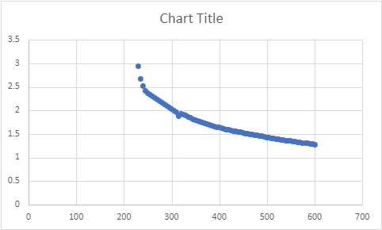

![Absorbance scan of Ethyl Cellulose solution after addition of PVA, showing a peak at 230 nm.](https://graph.microsoft.com/v1.0/siteCollections/persistai.sharepoint.com,44d5d7d9-9894-437b-a938-37f26f5ad066,95dec0fb-afca-4a24-af80-faf5e2f9cc75/onenote/resources/1-9a2bbbd4db3f08701c37908e1cddd242!1-e0399420-c246-494c-b96a-a04993f5c3ea/$value)

The effect of various additives on the solubility of IgG in PBS at high concentrations was also investigated. Additives were mixed with IgG in a 96-well plate and visually inspected for precipitation. The tested additives and their concentrations are listed in Table 3. Visual results showed that several additives, including Histidine, Sucrose, and Arginine, maintained solution clarity, whereas others resulted in visible precipitation (Figure 2).

**Table 3: Additives tested for their effect on high-concentration IgG solubility in PBS.**

|  |  |
| --- | --- |
| Additive | Concentration Range Tested |
| Sodium chloride | 0.15M - 6.2 mg/mL |
| Polysorbate 80 | 0.05 - 1 mg/mL |
| Sodium citrate | 0.001 - 0.03 M |
| pH | 5.2 - 7.2 |
| EDTA | 0.02 - 0.14 mg/mL |
| Histidine | 0.004 - 0.02 M |
| Trehalose | 20 - 80 mg/mL |
| Polysorbate 20 | 0.08 - 0.4 mg/mL |
| Sorbitol | 16 mg/mL |
| PEG 3350 | 4.7 mg/mL |
| Sodium Phosphate | 0.006 - 0.05 M |
| Sucrose | 25 - 90 mg/mL |
| Sodium Succinate | 0.05 M |
| Mannitol | 12 mg/mL |
| Sodium Acetate | 0.01 - 0.025 M |
| Adipic acid | 0.02 M |
| Methionine | 0.2 - 4.4 mg/mL |
| Arginine | 10 mg/mL |
| Poloxamer 188 | 0.2 - 1.5 mg/mL |

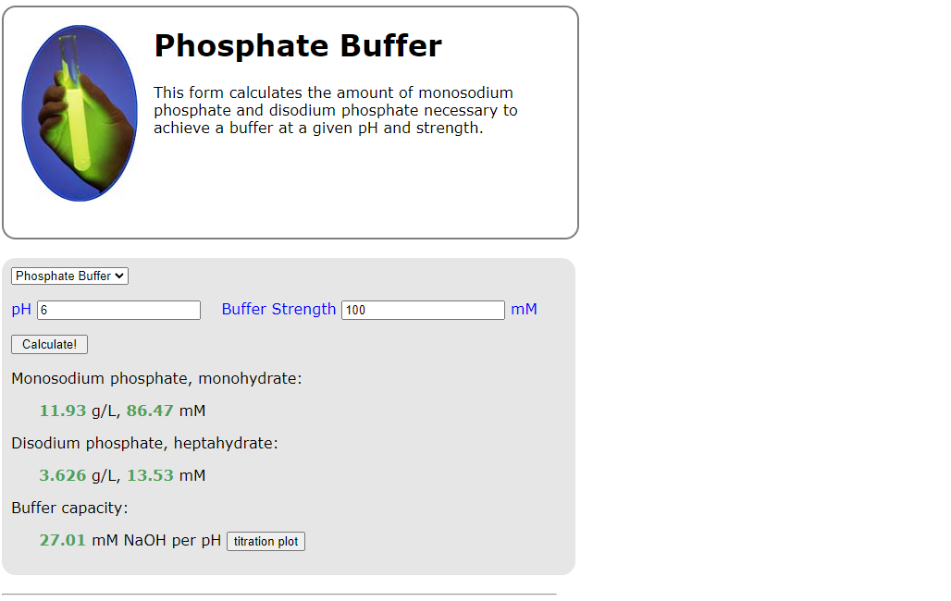

![Visual results of IgG solubility in the presence of various additives in a 96-well plate format. Clear wells indicate solubility, while opaque or precipitated wells indicate insolubility.](https://graph.microsoft.com/v1.0/siteCollections/persistai.sharepoint.com,44d5d7d9-9894-437b-a938-37f26f5ad066,95dec0fb-afca-4a24-af80-faf5e2f9cc75/onenote/resources/1-fd44e472a38c4bdfac1829d2b0178173!1-e0399420-c246-494c-b96a-a04993f5c3ea/$value)

## Microsphere Formulation and Morphological Characterization

The impact of formulation parameters on microsphere morphology was evaluated. Blank microspheres were prepared with decreasing concentrations of PLGA polymer, from 20% (MA14) down to 1% (MA18). Light microscopy revealed that higher PLGA concentrations (MA14) produced microspheres with uniform size and round shape, which appeared less dense. In contrast, lower PLGA concentrations (MA18) resulted in greater size dispersity, less uniform shape, and appeared denser (Figure 3).

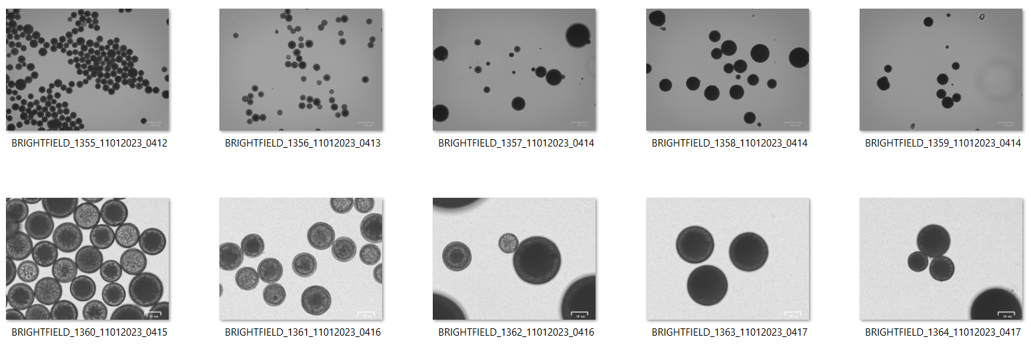

![ZOE microscope images of microspheres fabricated with varying PLGA concentrations. From left to right: MA14 (20%), MA15 (10%), MA16 (5%), MA17 (2%), MA18 (1%).](https://graph.microsoft.com/v1.0/siteCollections/persistai.sharepoint.com,44d5d7d9-9894-437b-a938-37f26f5ad066,95dec0fb-afca-4a24-af80-faf5e2f9cc75/onenote/resources/1-99e6b06977cb06851b5373a5ef84bb9e!1-e0399420-c246-494c-b96a-a04993f5c3ea/$value)

Scanning electron microscopy (SEM) was used to examine the surface and internal structure. The MA14 formulation (20% PLGA) produced particles with a relatively smooth but porous and jagged surface (Figure 4). Microspheres from the MA17 formulation (2% PLGA) showed different surface characteristics (Figure 5). The MA15 formulation (10% PLGA) was observed to have the greatest jagged appearance.



![SEM image of a microsphere from the MA14 formulation (20% PLGA).](https://graph.microsoft.com/v1.0/siteCollections/persistai.sharepoint.com,44d5d7d9-9894-437b-a938-37f26f5ad066,95dec0fb-afca-4a24-af80-faf5e2f9cc75/onenote/resources/1-1fb4e4fb2b8401f22c0bf3818a9cf912!1-e0399420-c246-494c-b96a-a04993f5c3ea/$value)



![SEM image of a microsphere from the MA17 formulation (2% PLGA).](https://graph.microsoft.com/v1.0/siteCollections/persistai.sharepoint.com,44d5d7d9-9894-437b-a938-37f26f5ad066,95dec0fb-afca-4a24-af80-faf5e2f9cc75/onenote/resources/1-4e056483ad1708f527d0c3cf23b0f14c!1-e0399420-c246-494c-b96a-a04993f5c3ea/$value)

The effect of the dispersed phase composition was investigated by varying the ratio of aqueous phase to oil phase using two different polymers, Innocore 1 (MA258-261) and Innocore 4 (MA262-265). Ratios of 1:2, 1:4, 1:8, and 1:16 were tested. Post-lyophilization microscopy images showed morphological changes dependent on both the polymer type and the phase ratio. For both polymers, increasing the oil phase proportion (e.g., 1:16 ratio) resulted in distinct particle morphologies (Figure 6, Figure 7).

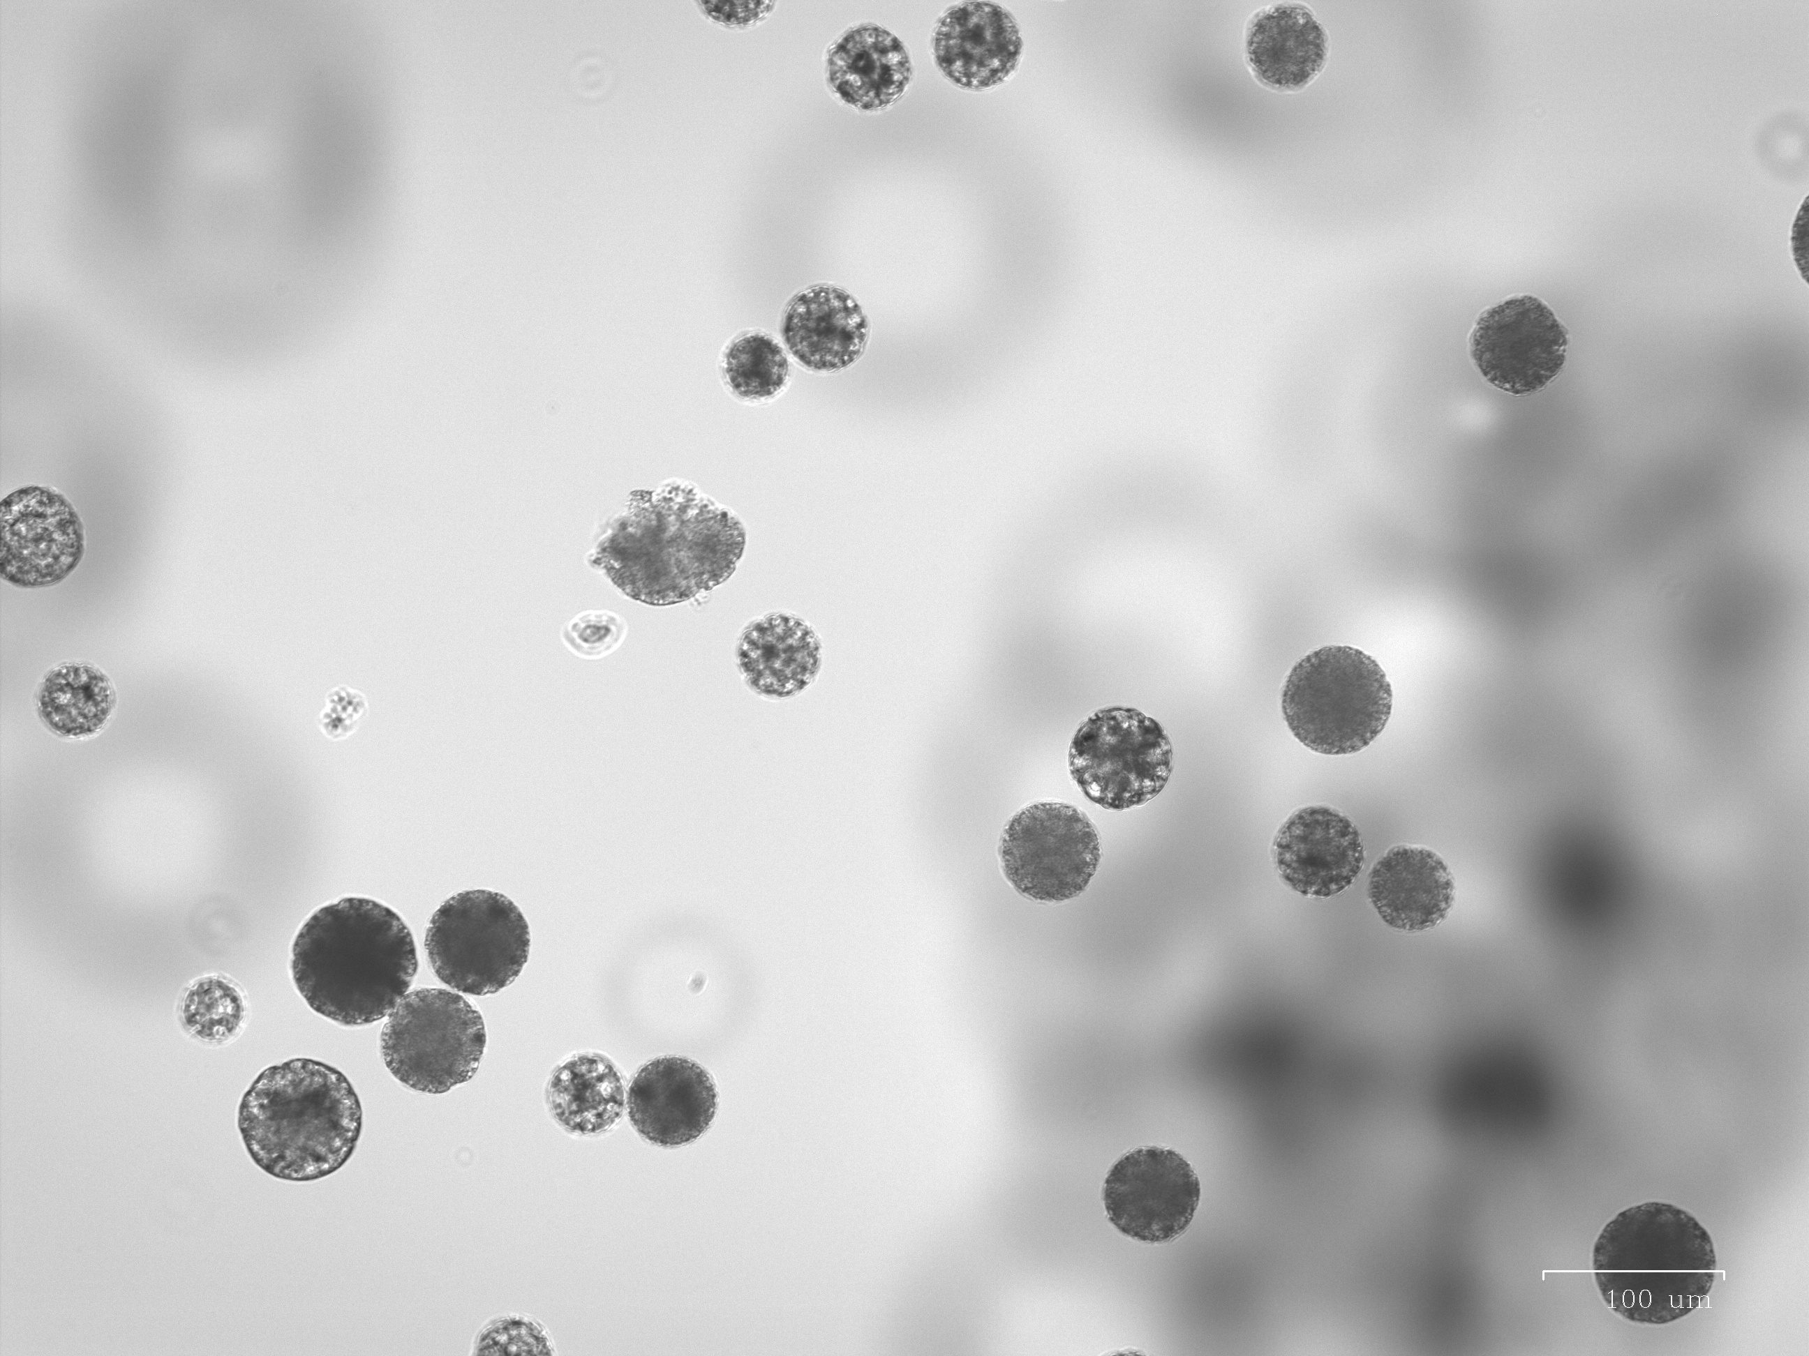

![Post-lyophilization morphology of MA261 microspheres (Innocore 1, 1:16 aqueous to oil ratio).](https://graph.microsoft.com/v1.0/siteCollections/persistai.sharepoint.com,44d5d7d9-9894-437b-a938-37f26f5ad066,95dec0fb-afca-4a24-af80-faf5e2f9cc75/onenote/resources/1-c87a641c07cf0af227697c1930142139!1-e0399420-c246-494c-b96a-a04993f5c3ea/$value)

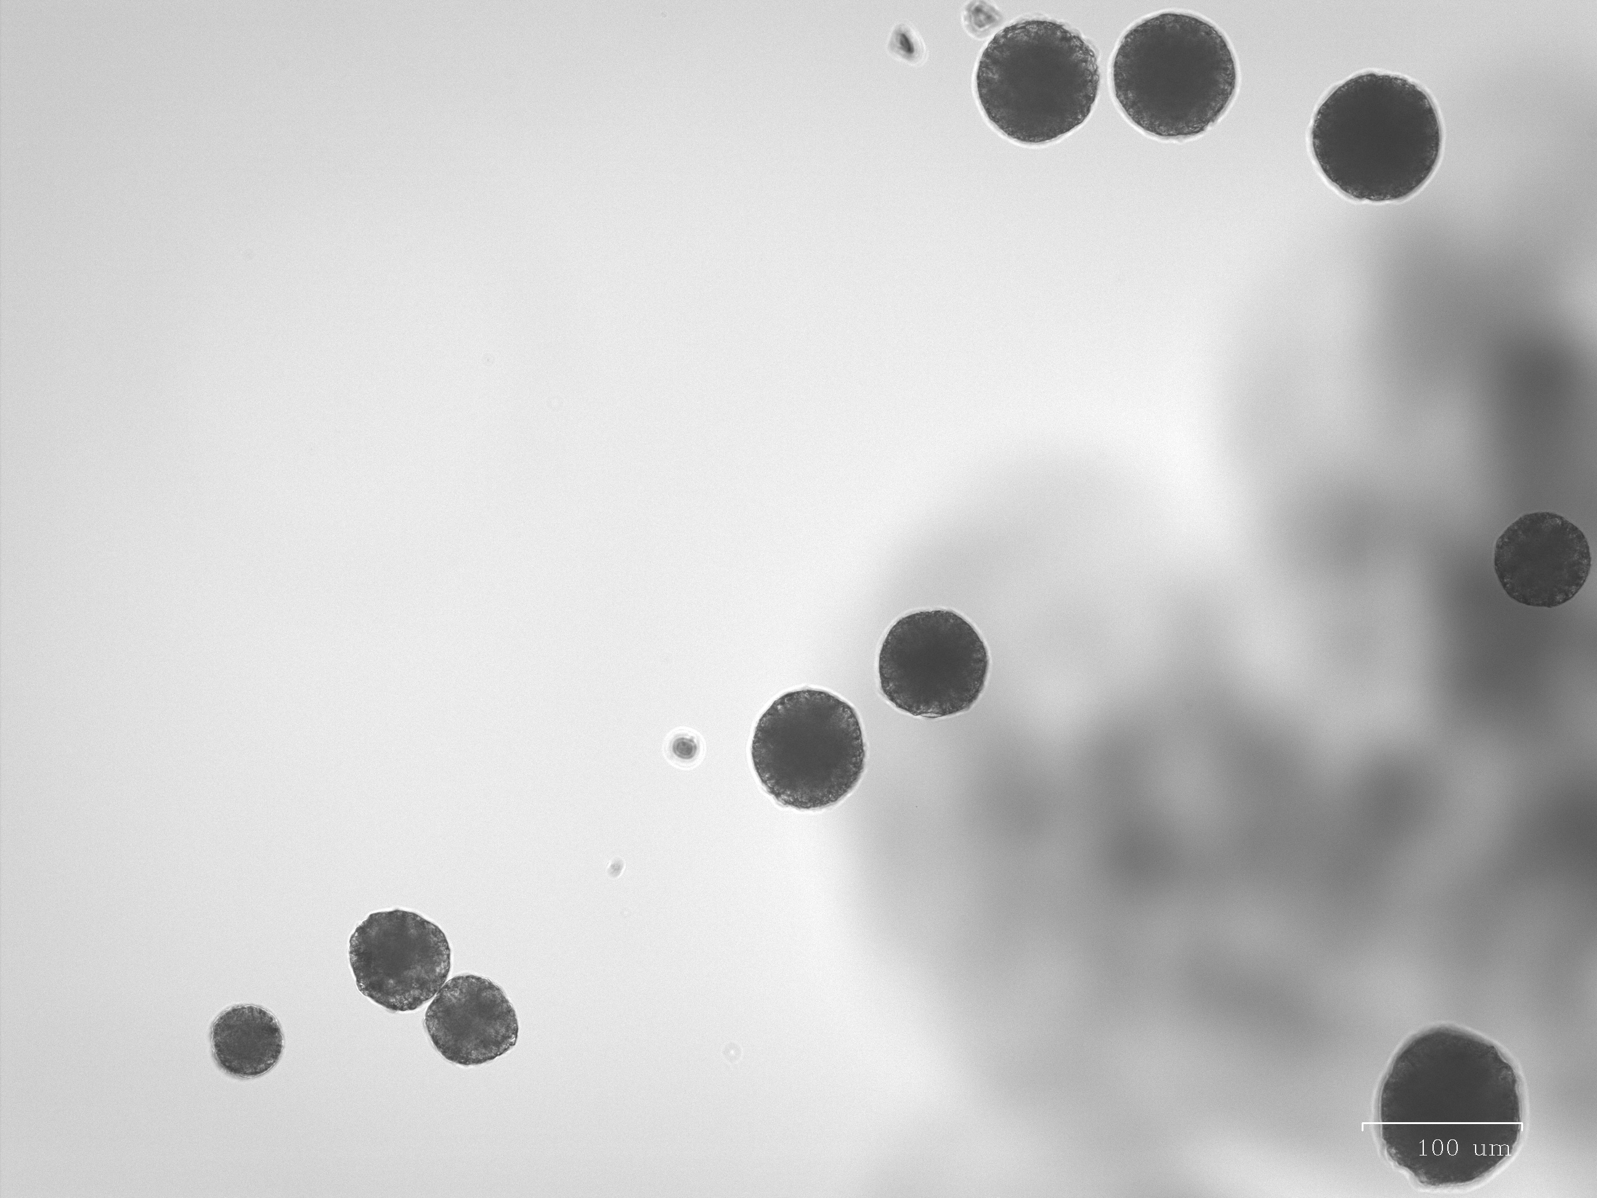

![Post-lyophilization morphology of MA265 microspheres (Innocore 4, 1:16 aqueous to oil ratio).](https://graph.microsoft.com/v1.0/siteCollections/persistai.sharepoint.com,44d5d7d9-9894-437b-a938-37f26f5ad066,95dec0fb-afca-4a24-af80-faf5e2f9cc75/onenote/resources/1-0588c998ede206851ab488ba14702d2f!1-e0399420-c246-494c-b96a-a04993f5c3ea/$value)

## Protein Loading into Microspheres

Initial attempts were made to post-load human IgG (hIgG) into pre-formed blank microspheres (MA14 and MA16). The effects of incubation time (1, 2, or 7 days) and hIgG concentration (0.2, 1, or 5 mg/mL) were evaluated. Across all conditions, negligible loading of hIgG into the microspheres was observed.

A subsequent experiment investigated whether excipients could improve the post-loading of hIgG into blank MA15 microspheres. Twenty-one different excipients were tested at a concentration of 1 mg/mL. Loading was quantified using a BCA assay. Several excipients interfered with the BCA assay, producing background noise. Of the excipients that did not interfere, Chitosan, Lecithin, and Polyallylamine HCl resulted in the highest observed IgG loading, at 3.74%, 2.64%, and 2.57%, respectively. The loading percentages for all tested excipients are detailed in Table 4.

**Table 4: Post-loading of hIgG into blank MA15 microspheres in the presence of various excipients. Loading was quantified by BCA assay.**

|  |  |  |  |  |
| --- | --- | --- | --- | --- |
| Formulation # | Excipient | BCA Assay Background Noise? (Y/N) | hIgG Loading | Improved Loading? (Y/N) |
| 1 | Alginic acid | N | 1.48% | Y |
| 2 | Ammonium sulfate | N | 1.04% | N |
| 3 | Castor oil | Y | 1.10% | N |
| 4 | Dextran 40 | N | 1.14% | N |
| 5 | Distearoyl-Phosphocholine | N | 1.44% | Y |
| 6 | Polyallylamine, HCl | N | 2.57% | Y |
| 7 | Polysorbate 80 | Y | 1.84% | ? |
| 8 | Arginine, HBr | N | 0.99% | N |
| 9 | Benzethonium chloride | Y | 3.82% | ? |
| 10 | Chitosan | N | 3.74% | Y |
| 11 | Lecithin 4C | N | 2.64% | Y |
| 12 | Polyacrylamide | N | 1.56% | Y |
| 13 | Polyethyleneimine | Y | 1.06% | N |
| 14 | Povidone (PVP) K30 | N | 1.21% | Y |
| 15 | Agarose, low gelling point | N | 1.89% | Y |
| 16 | Dextran sulfate | N | 1.07% | N |
| 17 | Ethyl cellulose | N | 1.96% | Y |
| 18 | Heparin 4C | N | 1.09% | N |
| 19 | Poly-L-Lysine 20C | Y | 1.80% | ? |
| 20 | Sodium hyaluronate 4C | N | 1.18% | N |
| 21 | Span 80 | Y | 1.08% | N |

## Assessment of Encapsulated Protein Activity

The activity of encapsulated enzymes was assessed qualitatively. The presence of active alkaline phosphatase released from MA10 and MA12 microspheres was tested using a BCIP/NBT substrate assay. After a 30-minute incubation, a slight indigo color change was observed in both the MA10 and MA12 microsphere solutions, indicating the presence of active enzyme. The Blank 12 microspheres, used as a negative control, showed no color change. Indigo-stained microspheres were also visible as a pellet in the MA10 and MA12 tubes (Figure 8).

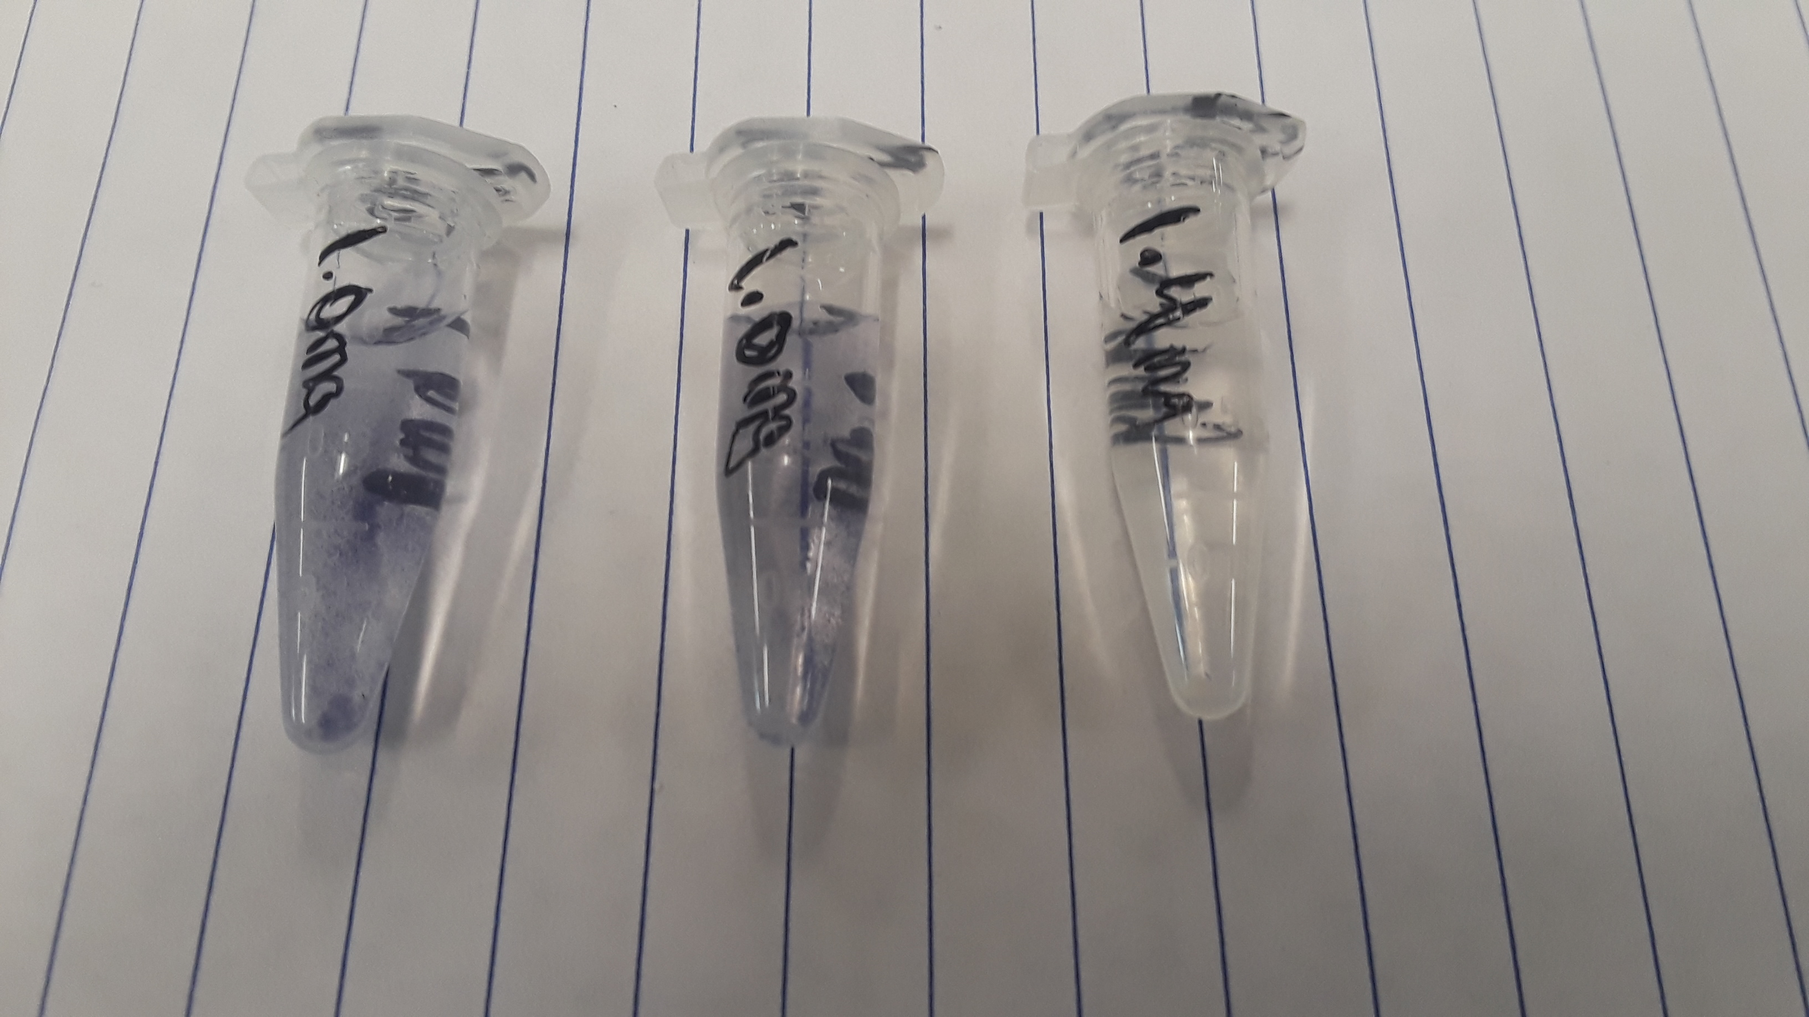

![Alkaline phosphatase activity detection. From left to right: MA10 microsphere solution, MA12 microsphere solution, and Blank 12 microsphere solution (negative control). The indigo color indicates a positive result.](https://graph.microsoft.com/v1.0/siteCollections/persistai.sharepoint.com,44d5d7d9-9894-437b-a938-37f26f5ad066,95dec0fb-afca-4a24-af80-faf5e2f9cc75/onenote/resources/1-c317fbd1205000c804a81450b3977b80!1-e0399420-c246-494c-b96a-a04993f5c3ea/$value)

The retained activity of encapsulated Goat Anti-Mouse IgG released from sample MA35 was evaluated using a dot blot immunoassay. The supernatant from MA35, with a calculated antibody concentration of 0.614 µg/mL, was compared against a standard curve of stock antibody (0.156 to 2.5 µg/mL). Visual assessment of the developed membrane showed that the signal intensity of the MA35 sample was between that of the 0.3125 µg/mL and 0.625 µg/mL standards, indicating that the encapsulated antibody retained its activity after release (Figure 9).

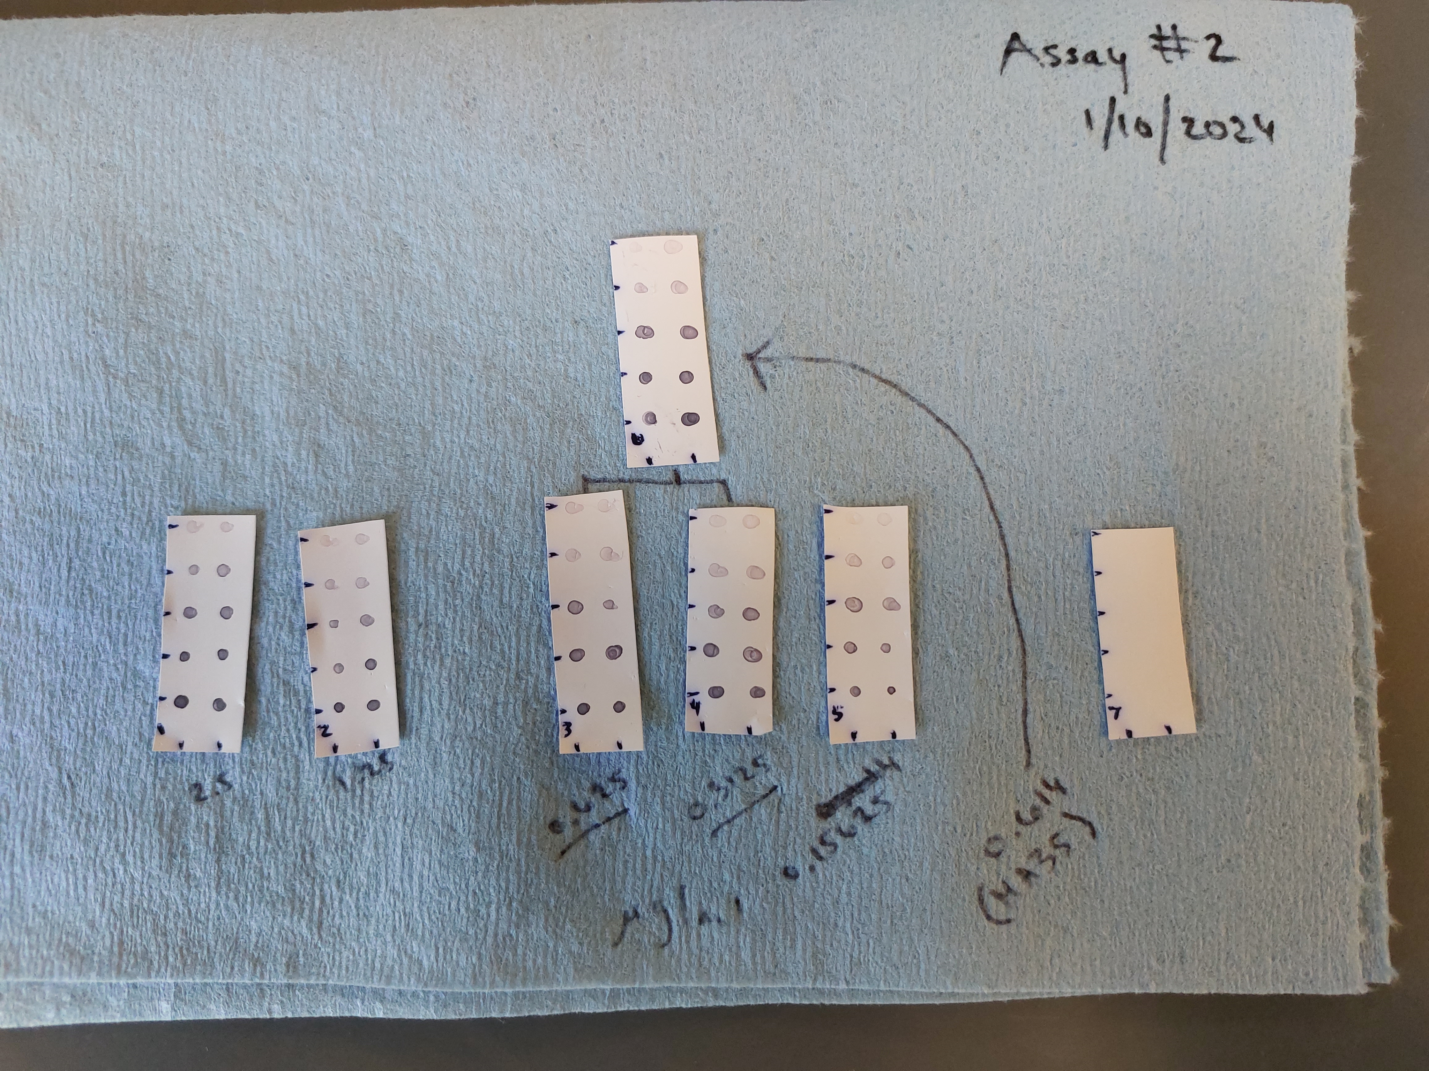

![Dot blot immunoassay results for Goat Anti-Mouse IgG activity. Membranes 1-5 represent the standard curve (2.5, 1.25, 0.625, 0.3125, 0.15625 µg/mL). Membrane 6 contains the released sample from MA35.](https://graph.microsoft.com/v1.0/siteCollections/persistai.sharepoint.com,44d5d7d9-9894-437b-a938-37f26f5ad066,95dec0fb-afca-4a24-af80-faf5e2f9cc75/onenote/resources/1-72a6e8d27a8400ce0882d88bda3a6098!1-e0399420-c246-494c-b96a-a04993f5c3ea/$value)

## Immunoassay Development and Analytical Controls

An ELISA was developed to quantify antibody release. Initial optimization experiments evaluated various concentrations of biotinylated secondary antibody (b-RxG) and streptavidin-HRP (SAV HRP), with dilutions ranging from 1:500 to 1:10,000. A dot blot assay to assess specificity showed non-specific binding of the detection antibodies to a human IgG negative control at concentrations down to 0.01 mg/mL.

Based on optimization, a final ELISA was performed using 1:10,000 b-RxG and 1:5,000 SAV HRP. Samples from MA228, incubated at 37°C and 4°C, were tested alongside a GxM standard curve ranging from 0 to 1 µg/mL. The resulting absorbance readings from the plate are shown in Figure 10.

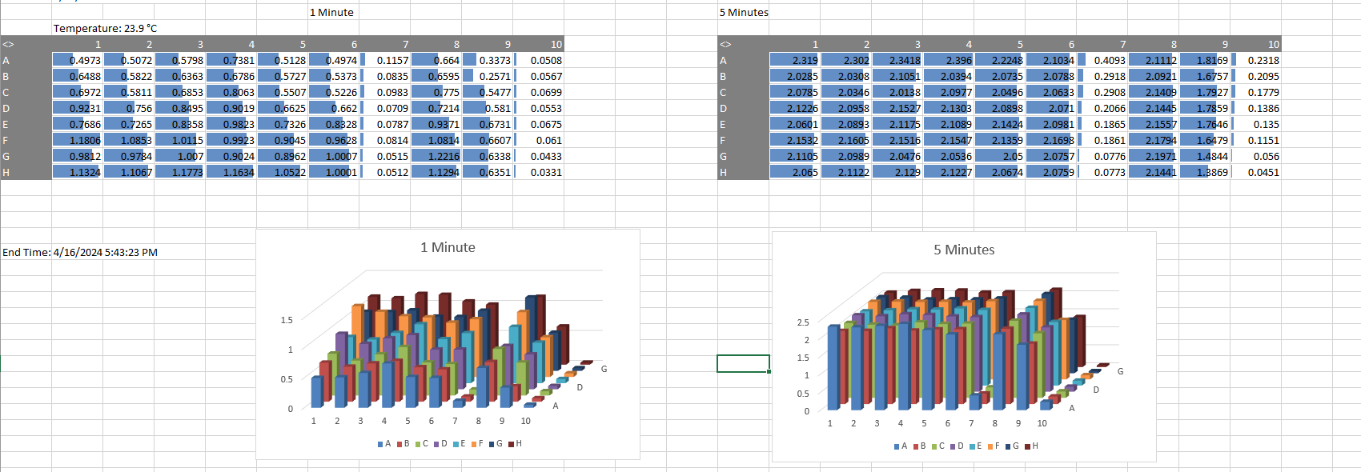

![ELISA plate reader results for MA228 samples. Columns 8 and 9 contain the MA228 samples collected after incubation at 37°C and 4°C, respectively. Rows A-G in columns 1-7 contain the GxM standard curve (1 to 0 µg/mL).](https://graph.microsoft.com/v1.0/siteCollections/persistai.sharepoint.com,44d5d7d9-9894-437b-a938-37f26f5ad066,95dec0fb-afca-4a24-af80-faf5e2f9cc75/onenote/resources/1-c41e97c67ba50dea2d6ace32ae851963!1-e0399420-c246-494c-b96a-a04993f5c3ea/$value)

Control experiments were performed for the BCA protein assay. Standard curves for Horseradish Peroxidase (HRP) and Alkaline Phosphatase (APT) were generated via 2x serial dilutions starting from 0.625 mg/mL. Both standard curves were linear with R² values greater than 0.99. A separate control experiment was conducted to determine if blank PLGA microspheres (MA14) interfere with the BCA assay. A dilution series of blank spheres (1.25 mg/mL to 0.15625 mg/mL) yielded low absorbance values (0.2028 down to 0.0945), which were substantially lower than typical absorbances for IgG-containing samples (e.g., ~0.6500) and close to the assay blank (0.0836). This indicated minimal interaction between the PLGA polymer and the BCA reagents.

# Conclusion

This investigation established and validated key analytical methods and explored critical formulation parameters for developing protein-loaded microspheres. The physical characteristics of the microspheres, including morphology and porosity, were tunable by modulating the PLGA polymer concentration. Initial attempts to post-load human IgG into blank microspheres yielded negligible results; however, a subsequent screen of 21 excipients identified several that significantly improved loading efficiency. Notably, Chitosan, Polyallylamine HCl, and Lecithin demonstrated substantial improvements in IgG uptake. Certain excipients, such as Polysorbate 80 and Benzethonium chloride, interfered with the BCA assay, which must be considered in future quantitative assessments.

A suite of analytical methods was validated for characterizing these formulations. The BCA assay was confirmed as a reliable method for quantifying encapsulated proteins, including IgG, HRP, and APT, with minimal interference from the base PLGA polymer. A dot blot immunoassay demonstrated that the activity of an encapsulated antibody was well-preserved following the encapsulation process. For quantifying released protein, an ELISA was optimized for sensitive detection, and a BCIP/NPT colorimetric assay proved effective for detecting active alkaline phosphatase. These validated methods and formulation findings provide a strong foundation for the continued development of controlled-release protein delivery systems.